Analyzing Factors Affecting Bike-Sharing Demand in Seoul
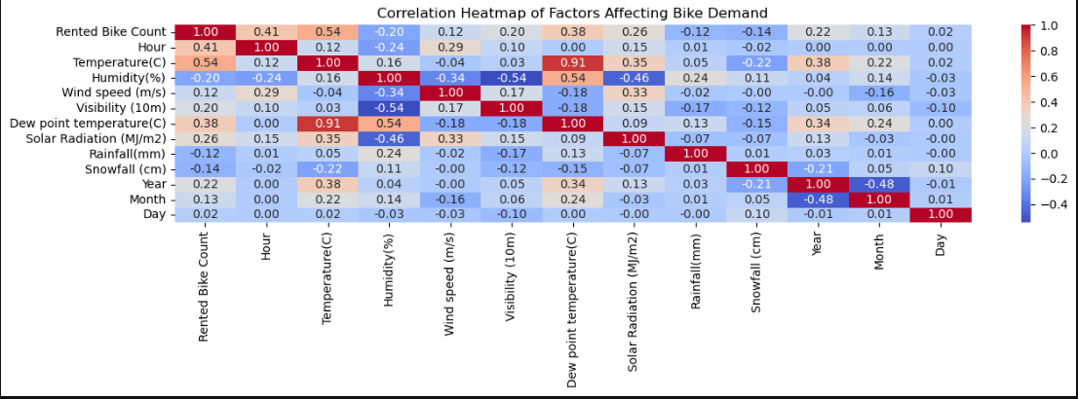 Correlation Heatmap of Factors Affecting Bike Demand.png
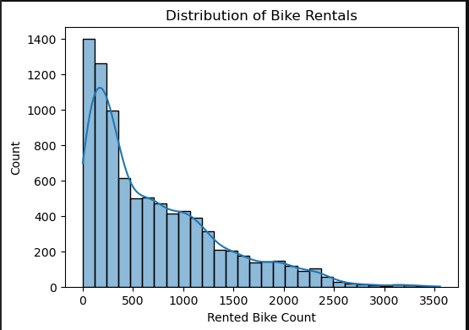Distribution of Bike Rentals.png

1. Introduction
Urban transportation systems are evolving to accommodate sustainable and flexible mobility options. Bike-sharing has emerged as a popular solution, providing affordable and eco-friendly transport alternatives. Understanding the factors that influence bike-sharing demand is essential for optimizing operations, policy-making, and infrastructure planning. This study analyzes the Seoul Bike Sharing dataset to explore environmental and temporal factors that shape rental demand patterns.

2. Methods
This analysis utilized the Seoul Bike Sharing dataset, which contains daily rental counts and weather-related variables. Data preprocessing included handling date formats, creating new temporal features (year, month, day, and weekday), and ensuring data quality. Exploratory Data Analysis (EDA) was performed to summarize key statistics, visualize distributions, and investigate relationships between bike rentals and explanatory variables such as temperature, humidity, wind speed, visibility, and precipitation. Python libraries including pandas, matplotlib, and seaborn were used for analysis and visualization.

3. Results
The analysis revealed distinct patterns in bike-sharing demand across temporal and environmental conditions.

Temporal Factors:
- Seasonality: Rentals showed clear seasonal variation, peaking in warmer months and dropping in winter. The average bike count in summer is over four times higher than in winter, while spring and autumn show similar demand levels.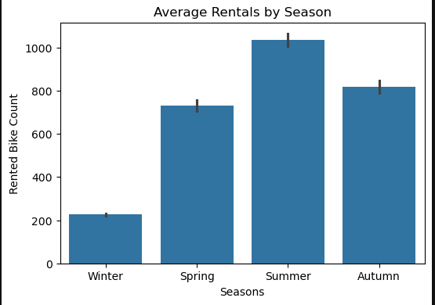 Average Rentals by Season.png
- Commuting Patterns: Weekdays exhibited higher demand compared to weekends, reflecting commuting patterns. A noticeable drop in rentals occurs on Sundays. 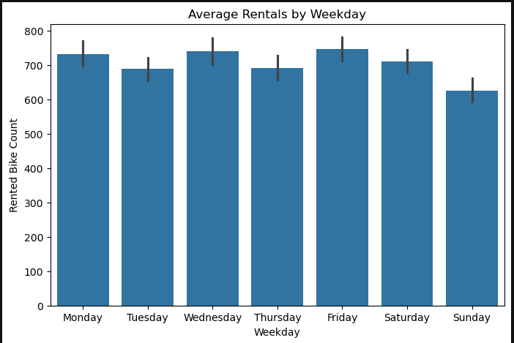Average Rentals by Weekday.pn
- Time of Day: The "Average Rentals by Hour of Day" chart shows two distinct peaks, likely corresponding to morning (around 8-9 AM) and evening (around 6-7 PM) commuting hours. Rentals are at their lowest between midnight and 5 AM. 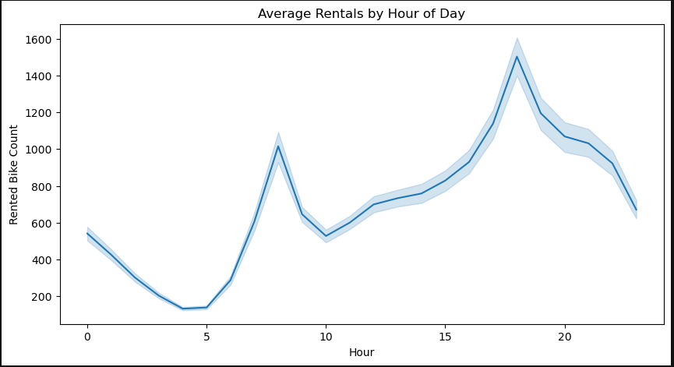Average Rentals by Hour of Day.png

Environmental Factors:
- Temperature: Temperature displayed a strong positive association with rentals, peaking between 20°C and 30°C. The correlation heatmap confirms this with a high positive correlation of 0.54. 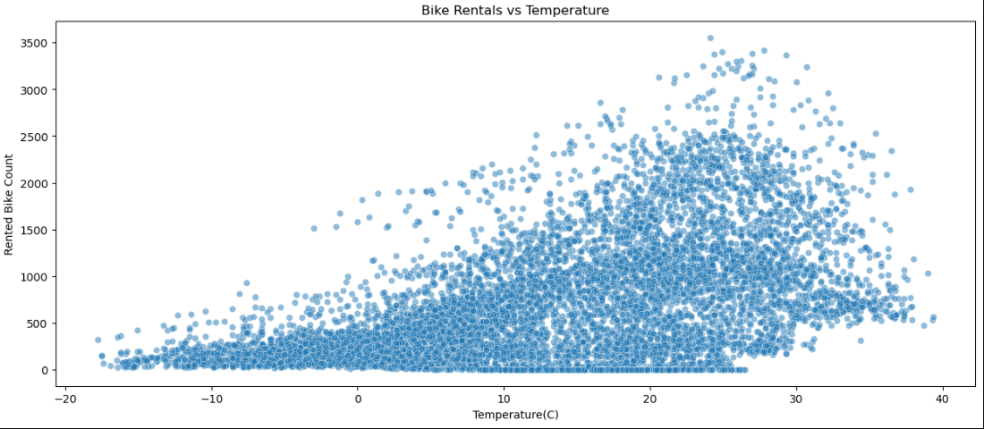Bike Rentals vs Temperature.jpg
- Precipitation: High humidity and precipitation negatively affected rentals, indicating a sensitivity to adverse weather. The "Impact of Rainfall on Bike Rentals" chart shows a sharp drop in rental numbers as rainfall increases. 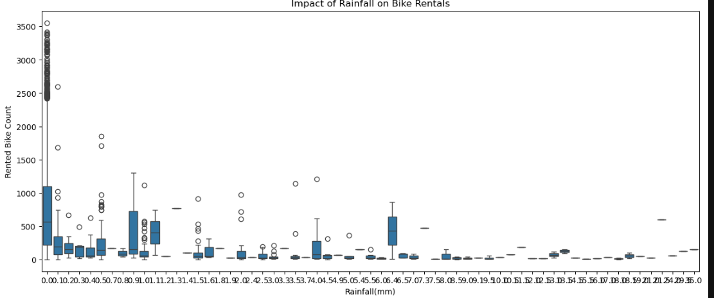Impact of Rainfall on Bike Rentals.png
- Humidity: The relationship between humidity and bike rentals is less straightforward. The highest number of rentals seems to occur in the mid-range of humidity (30% to 70%). The correlation heatmap shows a negative correlation of -0.20. 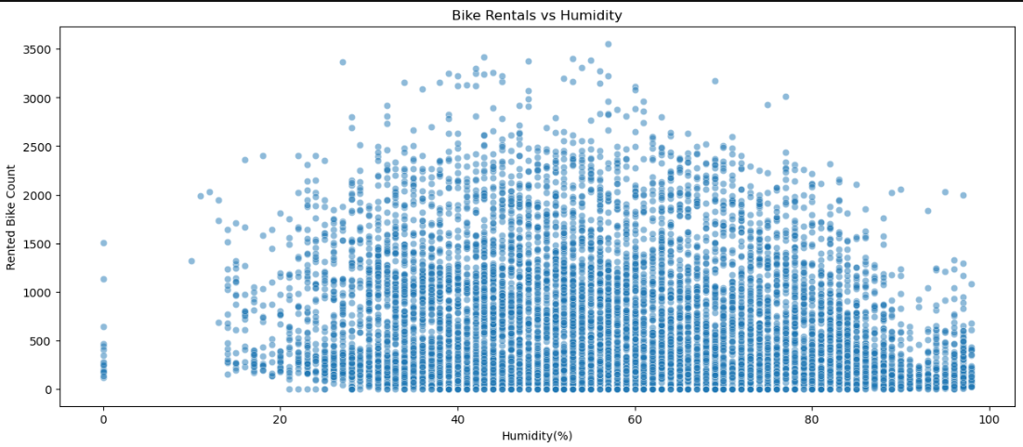Bike Rentals vs Humidity.jpg
- Other Weather Variables: Wind speed and visibility showed weaker but notable influences. The correlation heatmap also shows a positive correlation with solar radiation.

Operational and Socio-economic Factors:
- Operational Days: Rentals are significantly higher on functioning days compared to non-functioning days. 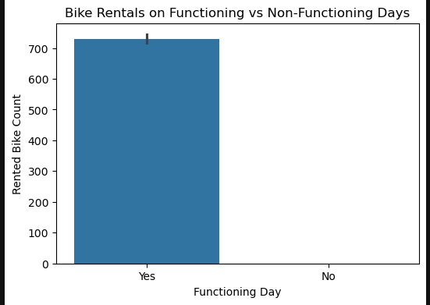Bike Rentals on Functioning vs Non-Functioning Days.png
- Holidays: Non-holiday periods see a much higher average bike rental count than holidays, suggesting that the system is primarily used for daily activities rather than recreational holiday use. 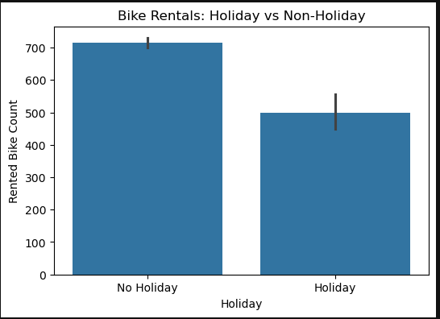Bike Rentals Holiday vs Non-Holiday.png

4. Discussion
These findings suggest that weather conditions and temporal cycles are significant determinants of bike-sharing demand in Seoul. The observed seasonal patterns align with previous studies, emphasizing the importance of weather-aware demand forecasting and dynamic resource allocation. For policymakers, the results underscore the need for integrating weather forecasts into bike-sharing operations to ensure user satisfaction and system reliability. Furthermore, infrastructure improvements such as covered bike lanes and better rain protection could mitigate the negative impact of adverse weather.

5. Conclusion
This study analyzed factors affecting bike-sharing demand in Seoul using a real-world dataset. The results highlight the crucial role of environmental and temporal variables in shaping rental behavior. Future research could expand the analysis using predictive models or comparative studies across multiple cities.

